**Title:**

Obtain IPV4 address when connected to VPN

**Summary/ Intro:**

Procedure to display IPV4 address when connected to VPN for support to be able to connect to the machine

**Steps:**

Step 1…

Click on Start button in the left bottom corner



Step 2

Type CMD and enter to open command prompt window

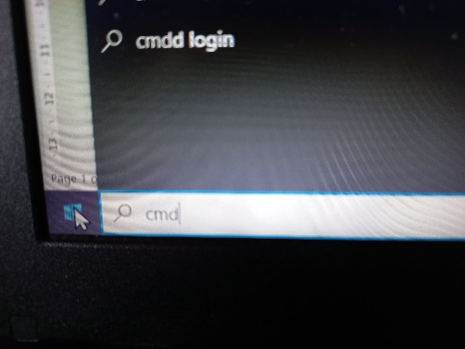

Step3

Type ipconfig in the command prompt window and enter

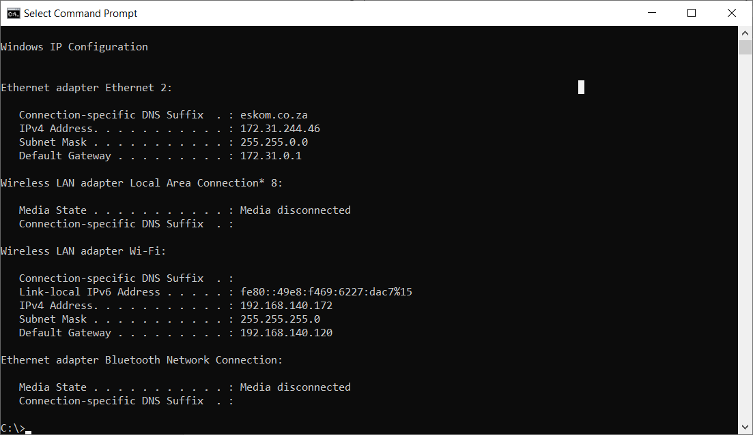

Step4

We need the IPV4 address below the eskom.co.za , sometime you need to scroll up for it to be visible

**Conclusion (Optional):**

Most of the time you need to scroll up to be able to see the IPV4 address below the eskom.co.za

**Created By:** Quintus Blom